**Assignment 1 : Intelligent Vending Machine**

**Title : The invention of an intelligent Vending Machine**

**Course : Computer Science**

**Name : Farhana Zulaikha binti Fadzli**

**Matric No : 143949**

**Group number : Z3**

**Lecturer : Prof Madya Dr Bahari bin Belaton**

**PROBLEM ANALYSIS**

1. *Input* :
2. Amount of money deposited into eWallet
3. Name of product chosen
4. Amount of topup
5. Name of currency chosen
6. Four digit number entered
7. *Output :*
8. Greeting
9. Date and time
10. Amount of money displayed
11. Choice of product
12. Price of product
13. Reminder to topup money if money is insufficient
14. Amount of user’s money after topup
15. Balance of money
16. Choice of currency
17. Currency exchange rate between MYR and Yen / BDT
18. Price of item in Japanese Yen / Bangladesh Taka
19. Balance in Japanese Yen / Bangladesh Taka
20. Four digits entered by user
21. Secret code generated
22. Sendoff greeting
23. Duration of transaction
24. *Constraints :*
25. If the amount of money deposited is sufficient or not;
26. Yes – Proceed
27. No – Topup your money
28. If each of the four digit entered is even or odd;
29. Even – Add digit by 11 and mod by 10
30. Odd – Add digit by 7 and mod by 10
31. If balance is :
32. 2 cents and below – Becomes floor
33. 3 cents and above – Becomes ceil
34. *Formula* :
35. Time : time_t now = time (0)
36. Random price : Price = static_cast <float> (rand ()) / (static_cast <float> (RAND_MAX / 55.30))
37. Amount of money if topup : userMoney = userMoney + topup
38. Balance : Balance = userMoney – price
39. Price of item in Japanese Yen : price = price + 27.54
40. Price of item in Bangladesh Taka : price + 19.88
41. Balance of item in Japanese Yen or Bangladesh Taka : newuserMoney – price
42. If digit entered is odd : digit entered = (digit + 7) % 10
43. If digit entered is even : digit entered = (digit + 11) % 10
44. Duration of transaction : (stop_s - start_s) / double (CLOCKS_PER_SEC)
45. *Expected samples of input / output :*
46. Input - Items : InstantNoodle, Bento, OrangeJuice, CocaCola, CornBread, IcedChocolate

Output - Price of item chosen

1. Input - Choice of currency : 1 (JapaneseYen), 2 (Bangladesh Taka)

Output – Currency exchange rate

1. Input – First digit, second digit, third digit, fourth digit

Output – Secret code generated

**IPO Chart**

|  |  |  |
| --- | --- | --- |
| INPUT | PROCESSING | OUTPUT |
| -Amount of money user deposited into eWallet  -Product user wants to purchase  -Amount of money user tops up into eWallet  -The currency user wants to choose  -First digit of secret code  -Second digit of secret code  -Third digit of secret code  -Fourth digit of secret code | -Generate current date and time from the system  -Generate random price by using this formula : price = static_cast <float> (rand()) / (static_cast <float> (RAND_MAX/55.30))  -Current user money if topup : userMoney = userMoney + topup  -Price of item in Yen : price = price + 27.54  -Price of item in Bangladesh Taka : price = price + 19.88  -User money in Japanese Yen / Bangladesh Taka : newuserMoney = userMoney + price  -Balance in Japanese Yen / Bangladesh Taka : balance = newuserMoney – price  -Generate secret code from four digit number; add even number by 11 and mod by 10, add odd number by 7 and mod by 10  -Swap first digit with fourth digit and second with third digit  -Calculate duration using : (stop_s - start_s) / double (CLOCKS_PER_SEC) | -Greeting when user uses the machine  -Current date and time  -A reminder to not deposit money more than RM55.30  -Amount of money displayed  -Choice of item  -Price of item  -Reminder to top up money if insufficient  -New amount of money if top up  -Balance of money  -Choice of currency  -Currency exchange rate  -Price of item in currency chosen  -Balance of money in currency chosen  -Secret code generated  -Sendoff greeting  -Duration of transaction |

**PSEUDOCODE**

Start

Read input_string

Print hello_welcome_to_intelligent_vending_machine greeting

Print date

Print time

Input amount_of_money

Input name_of_product

Print price_of_item

START

IF amount_of_money is insufficient

input topup_amount

END

Print user_balance

Input choice_of_currency

Print currency_exchange_rate

Print price_of_item_in_currency

Print user_balance_in_currency_chosen

Input first_digit

Input second_digit

Input third_digit

Input fourth_digit

START

IF digit is even

Add digit to 11 and mod by 10

ELSE

Add digit to 7 and mod by 10

END

Print secret_code

Print sendoff_greeting

Print duration_of_transaction

End

**FLOWCHART**

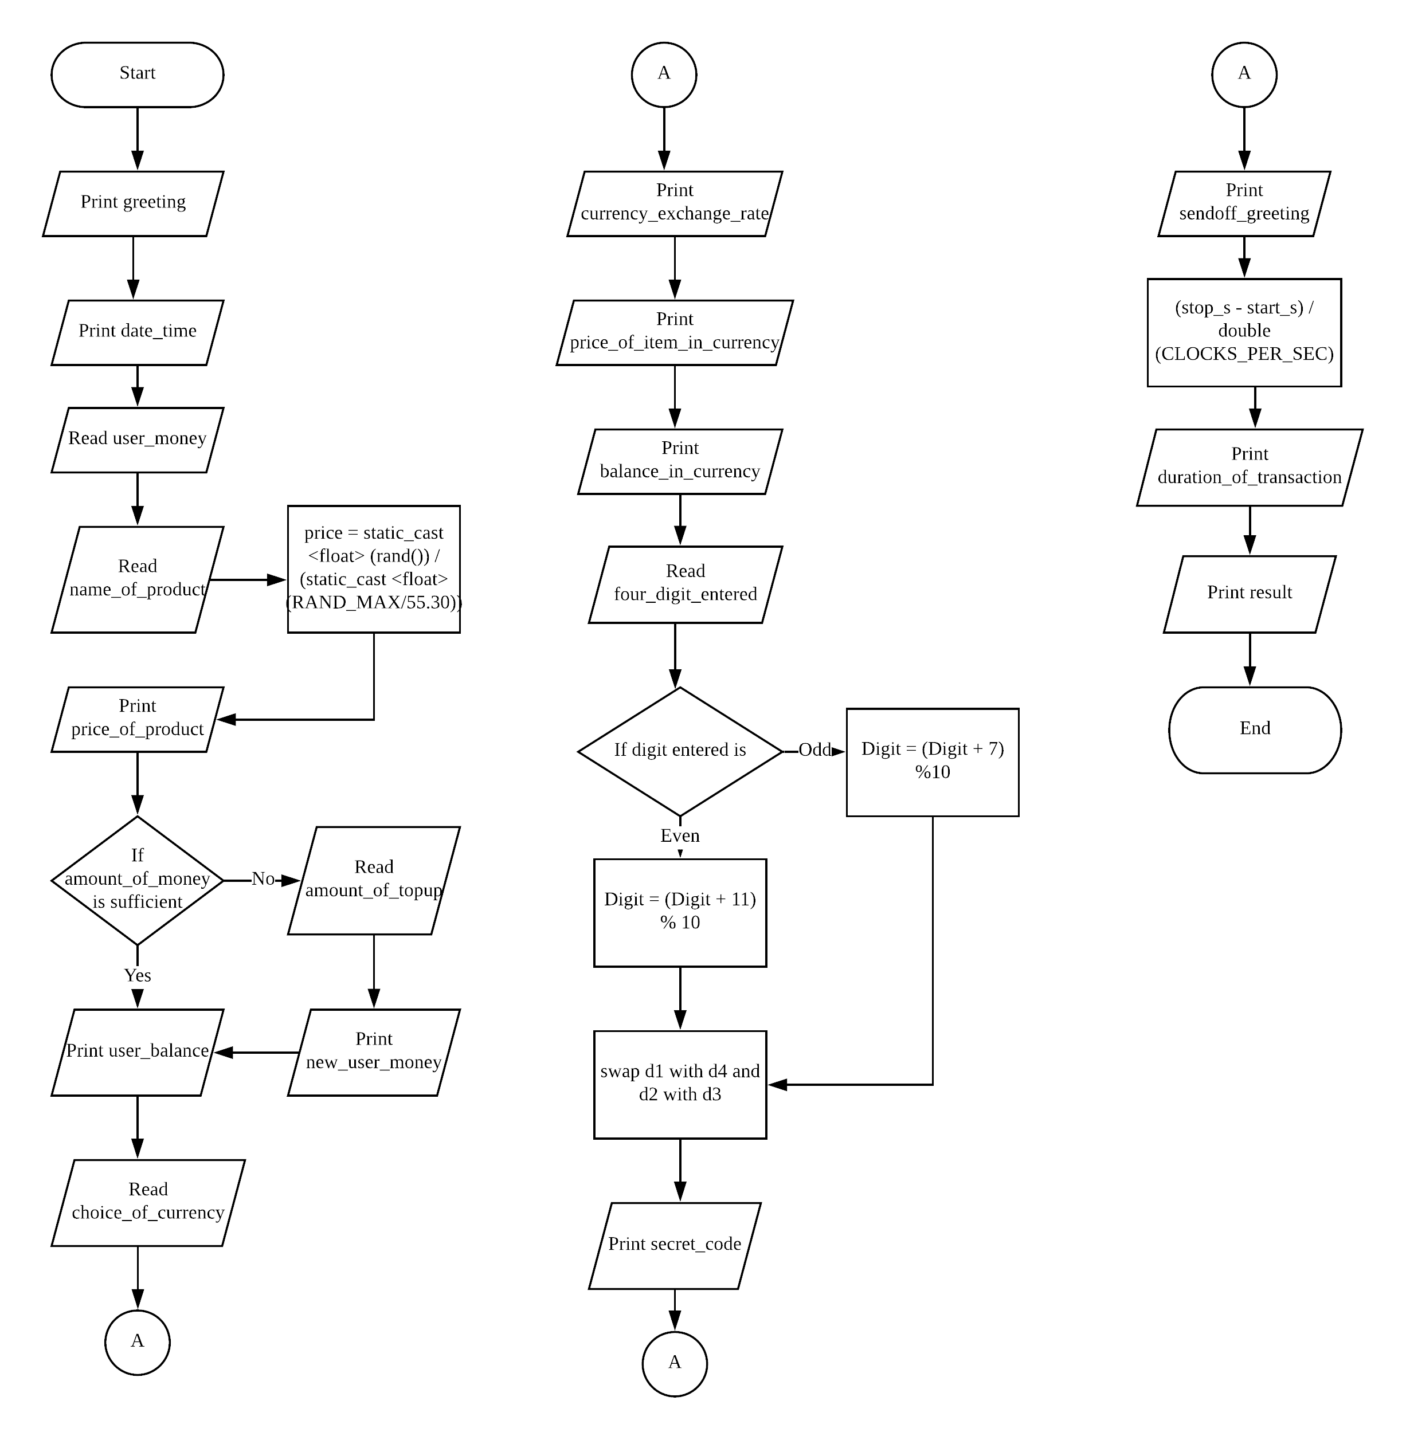

**DESK CHECK**

|  |  |  |  |  |  |  |
| --- | --- | --- | --- | --- | --- | --- |
| Line number | User money | Item | Price | Constraints | Input/output | Validity |
| 35 | RM32 | Instant noodle | RM20.08 |  | Your balance is RM11.92 | Valid |
| 54 | RM10 | Bento | RM20.01 | If usermoney < price; top up money | Input – RM30.00  Output - Amount of money is : RM40 | Valid |
| 66 |  |  |  | If currency entered is 1 – Japanese Yen : Print currency exchange rate  If currency entered is 2 – Bangladesh Taka : Print currency exchange rate | Input – 3  Output - none | Invalid |
| 157 |  |  |  | If digit entered is even : digit = (digit + 11) % 10  If digit entered is odd : digit = (digit +7) % 10  Swap d1 with d4 and d2 with d3 | Input –  D1 : 4  D2 : 3  D3 : 9  D4 –:0  Output –  Your secret code is 1605 | Valid |

**C++ Program listings**

1. #include <iostream>
2. #include <string>
3. #include <time.h>
4. #include <iomanip>
5. #include <chrono>
6. #include <math.h>
7. using namespace std;
8. int main ()
9. {
10. float userMoney;
11. int d1 = 0;
12. int d2 = 0;
13. int d3 = 0;
14. int d4 = 0;
15. int swap = 0;
16. string userChoice;
17. float price;
18. float topup;
19. float balance;
20. float currency;
21. float newuserMoney;
22. int start_s = clock ();
24. cout << "Hello, welcome to Intelligent Vending Machine " << endl;
25. //current date/time based on current system
26. time_t now = time (0);
27. //convert now to string form
28. char* dt = ctime(&now);
30. cout << "Date and time : " << dt << endl;
32. cout << "Amount of money deposited must not be more than RM 55.30 " << endl;
33. cout << "Amount of money : RM " ;
34. cin >> userMoney;
36. cout << "Enter name of item, choose from the following : InstantNoodle, IcedChocolate, CornBread, Bento, CocaCola, OrangeJuice " << endl;
37. cin >> userChoice;
39. //generate random number not more than 55.30
41. srand((unsigned)time(0));
42. price = static_cast <float> (rand()) / (static_cast <float> (RAND_MAX/55.30));
43. cout << "Price of item is : RM " ;
44. cout << setprecision (2) << fixed << price << endl;
46. //check if userMoney is sufficient enough to purchase the item
47. if ( userMoney < price )
48. {
49. cout << "Please top up your money " << endl;
50. cin >> topup;
51. userMoney = userMoney + topup;
52. cout << "Amount of money : RM " << setprecision (2) << fixed << userMoney << endl;
54. }
56. balance = userMoney - price;
57. cout << "Your balance is : RM " << setprecision (2) << fixed << balance << endl;
59. cout << "Choose the currency exchange rate you would like to display from the following : 1 - Japanese Yen, 2 - BangladeshTaka : " << endl;
60. cin >> currency;
62. if ( currency == 1 )
63. {
64. cout << "1 MYR = 27. 54 Yen " << endl;
65. price = price + 27.54;
66. cout << "Price of item is : Yen " << price << endl;
67. newuserMoney = userMoney + price;
68. balance = newuserMoney - price;
69. cout << "Your balance : Yen " << balance << endl;
71. }
73. else if ( currency == 2 )
74. {
75. cout << "1 MYR = 19. 88 BDT " << endl;
76. price = price + 19.88;
77. cout << "Price of item is : BDT " << price << endl;
78. newuserMoney = userMoney + price;
79. balance = newuserMoney - price;
80. cout << "Your balance is : BDT " << balance << endl;
82. }
84. //generatesecretcodefromfourdigitnumber
86. cout << "Enter 1st digit : " ;
87. cin >> d1;
88. cout << "Enter 2nd digit : " ;
89. cin >> d2;
90. cout << "Enter 3rd digit : " ;
91. cin >> d3;
92. cout << "Enter 4th digit : " ;
93. cin >> d4;
95. if ( d1 % 2 == 0 )
96. {
97. d1 = d1 + 11;
98. d1 = d1 % 10;
100. }
101. else
102. {
103. d1 = d1 + 7;
104. d1 = d1 % 10;
106. }
108. if ( d2 % 2 == 0 )
109. {
110. d2 = d2 + 11;
111. d2 = d2 % 10;
113. }
114. else
115. {
116. d2 = d2 + 7;
117. d2 = d2 % 10;
119. }
121. if ( d3 % 2 == 0)
122. {
123. d3 = d3 + 11;
124. d3 = d3 % 10;
126. }
127. else
128. {
129. d3 = d3 + 7;
130. d3 = d3 % 10;
132. }
133. if ( d4 % 2 == 0 )
134. {
135. d4 = d4 + 11;
136. d4 = d4 % 10;
138. }
139. else
140. {
141. d4 = d4 + 7;
142. d4 = d4 % 10;
144. }
146. swap = d1;
147. d1 = d4;
148. d4 = swap;
150. swap = d2;
151. d2 = d3;
152. d3 = swap;
154. cout << "Your secret code is : " << d1 << d2 << d3 << d4 << endl;
156. cout << "Thank you for using! Have a nice day! " << endl;
158. int stop_s = clock ();
160. cout << "Duration of transaction : " << (stop_s - start_s) / double (CLOCKS_PER_SEC) << endl;
162. return 0;
164. }

**ACTUAL RUNS**

